**KWAME NKRUMAH UNIVERSITY OF SCIENCE AND TECHNOLOGY**

**COLLEGE OF SCIENCE**



**DEPARTMENT OF COMPUTER SCIENCE**

**FACULTY OF PHYSICAL AND COMPUTATIONAL SCIENCE**

**WEB BASED ADVERTISEMENT OF PRODUCTS (GET MARKET)**

**ADJETEY RICHARD ADJETEY**

**INDEX NUMBER: 4602118**

**Table of contents**

**CHAPTER ONE………………………………………………………………………… 4**

**Introduction**

**1.0 – Background**

**1.1 – Problem statement**

**1.2 – Aim of Project**

**1.3 – Specific Objectives**

**1.4 – Project Scope**

**1.5 – Project Justification**

**1.6 – Project motivation**

**1.7 – Project Beneficiaries**

**CHAPTER TWO………………………………………………………………………… 6**

**Review of related works**

**2.1 – Overview of System**

**2.1.1 – Good features and Bad features**

**CHAPTER THREE ……………………………………………………………………… 7**

**Methodology**

**3.0 – Overview of the Proposed System**

**3.1 – Project method adopted and justification**

**3.2 – Requirement specification**

**3.2.1 – Functional requirements of the system**

**3.2.1.1 – Non-Functional requirements of the system**

**3.2.2 – UML models**

**3.3 – Architectural Design of the Proposed System**

**3.3.1.1 – Database Design**

**3.3.1.2 – User interface Design**

**CHAPTER FOUR……………………………………………………………………… 20**

**Implementation and testing**

**4.0 – Database schema**

**4.3 – User interfaces**

**4.3.1 – Testing**

**4.4.3 – Deployment model and platforms**

**CHAPTER FIVE………………………………………………………………………… 24**

**Conclusions and references**

**5.0 – Conclusion**

**5.2 - References**

**CHAPTER ONE**

**INTRODUCTION**

**BACKGROUND**

There are many online e-commerce web applications in Ghana. Jumia, OLX, Tonaton and many more. They are very good web applications which are moving the country in a positive direction in this technological age. These web applications are making buying and selling between customers and client holders very easy. With a few clicks and easy forms to fill buying and selling is made easy. But these web applications target the country as a whole so how about an application to target the KNUST student environment for us to get to know clients better, our customers, those selling and those with the aim for business. They are many business ventures within and outside own by students in KNUST but to know them is an issue. It has to be among our peers, social media platforms like Instagram and posting of flyers around the school. Business can move faster or slower depending on how well people get to know about your business. Will it not be positive if a web application for buying and selling is created like Jumia, OLX and others but in KNUST?? Get Market, a web application will provide a platform for students to advertise and sell their products for example; mobile phones, shirts, sobolo business and many more. With Get market students provide specific and important details for other students to know about them for example; phone and location easily.

**PROBLEM STATEMENT**

KNUST has its various ways student can advertise their products. That is through WhatsApp, Snapchat and other social media platform and flyers. And also, recommendations from peers. These ways are what has carried advertisement for a longtime now but looking at the disadvantage of the fact that the stress to let other students know about your business and for students to contact sellers for the products they want is a big factor. Get market provides the solution. The proposed system handles the problem of public or student exposure to the advertisement of products.

**AIM OF PROJECT**

The primary aim of Get market is to expose advertisement of products to students better and at a faster rate. Get market will provide a platform that is a web-based application to post and advertise products ranging from clothes, mobile phones, food and many more. Get market will reduce the cost for students to make flyers and post them around the school, reduce time and create an easy search for products.

**SPECIFIC OBJECTIVES**

There are some specific objectives to achieve the general aim of this project. These are;

1. To design an attractive user interface for the proposed system.
2. To design a working web application system for the posting and advertisement of products.
3. To test the proposed system and see if it meets the criteria and proposed idea it aims to meet.
4. To specify and analyze requirements of the proposed system effectively and how it can affect the schooling environment.

**PROECT SCOPE**

The scope of the project is designing and developing a web-based advertisement platform called Get market. The web-based platform performs activities like:

1. Posting products based on the category you choose that is creating a business platform For example; Posting T-shirts under the category clothes.
2. Promote the advertisement of products.
3. Users can view and search for the details of the products posted. Example; Location of seller, Bomso , Evandy Hostel.

**PROJECT JUSTIFICATION**

Get market moves advertisement in the right direction. It creates a more digitized e-commerce environment for students in KNUST making advertisement easy and effective. Why the need for Get market?? Because it creates a platform for students to publicize and boost products they want to sell without any challenge and other students in turn will get to know about these products to get in contact with sellers and buy.

**PROJECT MOTIVATION**

Get market because, a large number of students wish to create a business platform but the fear that their business will be known by a few or promoted at a faster rate is a boost to kill their confidence. For example; a student wishes to sell mobile phones. He posts his flyer on his social media platforms for students to be informed about his products. Flyers will be printed at a cost and posted on hostels’ notice boards for students to read. After a while the flyers will be removed. Flyers will also be posted on walls and other places for students to read and after a while they wear off. Get market makes all this simple and easy without any difficulty, without any cost to print flyers and post it around. Students will have the privilege to surf and buy what they want on Get market web application and their advertisement can last for as long as they want.

**PROJECT BENEFICIARIES**

After the project is completed the group of people that will benefit more will be students or anyone who wishes to advertise their product in the school. They can;

1. Post and advertise their products easily
2. Surf and choose what product they want and in turn get the required information on the sale.

**CHAPTER TWO**

**REVIEW OF RELATED SYSTEMS**

Currently in KNUST there are no web applications similar to the project proposed. There are applications to support what Get market offers. In KNUST social media platforms like WhatsApp and Instagram are what students who want to sell use.

With WhatsApp, students who wish to create a business platform will have to post their flyers on their WhatsApp status for their contacts to view and those who wish to buy will reply. It is important that the student knows a lot of people and has a big contact list for publicity. The students who have then seen the flyer on the seller’s status will in turn ask their peers to do the same hoping others will contact the main seller. And does basically creating a business platform.

With Instagram it’s about creating a business page and profile based on what you want to sell. You need to have a lot of pictures of the products you want to sell. The biggest downside is how to generate followers for people to view your profile and page. At least a minimum of 1000 followers will get you going which is not something easy. Instagram also gives you the chance to advertise your pages and profile but at a cost.

Get market will put an ease the worries of increasing your business popularity because it will be a platform where everyone can visit and every student will visit.

**CHAPTER THREE**

**METHODOLOGY**

**OVERVIEW OF PROPOSED SYSTEM**

**Definition.**

Get market is web application. The proposed system basically creates an environment and a platform to boost your business. Future customers will not have any difficulty looking for what they want. Generally creating a known customer base will not be a worry. You can put into details everything important to be contacted and for publicity for example; your WhatsApp number to your Instagram profile or page.

**Get market and basic functions.**

The platform gives the user (student) the chance to create a profile or account. It is one of the most important features because without creating an account or profile accessing other features will not be possible. After creating your account feel free to post whatever you wish to sell and advertise. You can edit and delete your product. Get market will display the necessary details to view to others want to buy so therefore it is important to enter the right details.

**PROJECT METHOD AND JUSTIFICATION**

Waterfall Methodology

[Waterfall](https://zenkit.com/en/blog/agile-vs-waterfall/) is a linear, sequential design approach where progress flows downwards in one direction. It emphasizes that you are only able to move onto the next phase of development once the current phase has been completed. The phases are followed in the following order:

1. System and software requirements
2. Analysis
3. Design
4. Coding
5. Testing
6. Operations

The progress of the proposed system was used by each phase of the waterfall methodology. From the system and software requirements to design the project to every step-by-step analysis, design, coding, testing and operations all taken into consideration to build the project Get market.

System and software requirements

To make the implementation of the system easy, user friendly, we will use the following tools;

Software requirements

|  |  |
| --- | --- |
| Software tools | Function of the tool |
| Operating System: Windows 10 | To install the various software such as sublime text and xampp server |
| Sublime text | To write html and php code |
| MS Word 2016 | To write documentation |
| Script Language: JavaScript | To validate forms |
| Markup language: Php, Html | To develop interface and connect with the database |
| Xampp Server | To run the php command |
| Database server: PhpMyadmin (MySql database | To store the data entered by the system |

Hardware requirements

|  |  |
| --- | --- |
| Hardware tools | Function of the tools |
| Hard drive | To hold and keep files |
| Laptop | To do the project |
| Router | For internet connectivity |

**REQUIREMENTS SPECIFICATION**

User requirements are requirement that is used to add further detail to the project’s requirements. They are called user requirements because they are from a user’s perspective and the focus of user requirement describe tasks the user must be able to accomplish in order to fulfill the stated project’s requirements. The requirements specification can be categorized into functional and non-functional requirements.

**FUNCTIONAL REQUIREMENTS OF THE SYSTEM**

Functional requirements try to focus on the intended behavior of the system or what the proposed project will do. Get market is designed as a way that enables the ones who participate to utilize information at all levels of the features designed. These are;

1. Get market should let users create and account or profile.
2. Get market should allow users login.
3. Get market will allow users view products and their respective details.
4. Get market should allow users to post their products. They will fill in a form with the needed details.
5. Users can edit products they post.
6. Users can edit their account details.
7. Users can delete their products.
8. Users can search for products.

**NON-FUNCTIONAL REQUIREMENTS OF THE SYSTEM**

Nonfunctional requirements are requirements that are not necessarily needed but useful for describing the project. It essentially specifies how the proposed project should behave besides the functional requirements to reflect the quality of the system. Some of the non- functional requirements are:

1. The data that are saved shall be reused if needed.
2. Proper login authentication will be provided for better security.
3. Data retrieving process should take less time.
4. Specific data will be allowed to the user for proper flow of the proposed project.
5. The proposed project can be used on any device anywhere.

**UML MODELS**

Use Case diagram

The use case model, represented in UML with use case diagrams, describes the functionality of the project from the user’s point of view. A use case diagram is a visual picture of the different scenarios of interaction between system actors and use cases. Before drawing use case diagram, we will describe the project’s actors and use cases. Use case diagram consists of objects to it. Thus are:

1. Actors are the persons that interact to the proposed project and they are the main beneficiary of the project.
2. Use case is a diagram that shows the function of the actors.
3. System boundary is the working area of the use case.
4. Relationship links the actor to the use case to show the function is linked to whom.

Users or actors of the proposed project;

1. Customers (students or anyone interested in advertising their products.)

Use cases of the proposed project;

1. Create account.
2. Login.
3. Edit profile.
4. Post product.
5. View posted product details.
6. Edit posted product.
7. Delete posted product.
8. Search for product.

Use case diagram:

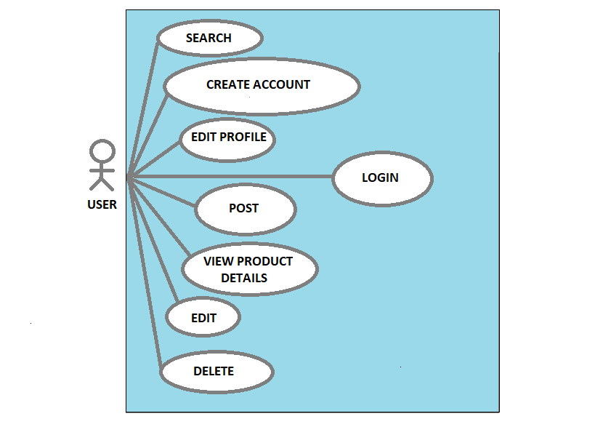

Use case diagram description

|  |  |
| --- | --- |
| Use case name | Create account |
| Actor | User |
| Description | The user enters the necessary details to create an account |
| Precondition | The user should fill in the necessary fields and be sure that passwords match |
| Basic course of action | User action:   1. Open register page 2. Fill in the necessary information 3. Click on the register button.   System action:   1. Display the register page 2. Check the information to be entered 3. If the information is right and meets the conditions let the user login. |

|  |  |
| --- | --- |
| Use case name | Login |
| Actor | User |
| Description | The user enters email and password in order to login |
| Precondition | The users should have an email and password |
| Basic course of action | User action:   1. Open login page 2. Enter email and password 3. Click login button   System action:   1. Display login form 2. Check email and password 3. If the email and password is correct login the user. |

|  |  |
| --- | --- |
| Use case name | Post |
| Actor | User |
| Description | The user fills a form to advertise and post product |
| Precondition | The users should follow form format and enter the right details |
| Basic course of action | User action:   1. Opens the form page 2. Enters the necessary information 3. Click the post button   System action:   1. Display the form page 2. Check information entered in the form 3. If the information meets the conditions allow the product to be posted and displayed. |

|  |  |
| --- | --- |
| Use case name | Edit profile |
| Actor | User |
| Description | The user edits profile and changes password |
| Precondition | The users should follow format and edit profile properly |
| Basic course of action | User action:   1. Open edit profile page 2. Enter the right information to edit profile 3. Click edit button 4. Click change password button   System action:   1. Display edit profile form 2. Check input entry. 3. If the entry matches edit profile. |

|  |  |
| --- | --- |
| Use case name | View product details |
| Actor | User |
| Description | The user views product details displayed |
| Precondition | The users must click on the product displayed on the page |
| Basic course of action | User action:   1. Click on the product displayed on the page.   System action:   1. Display product details. |

|  |  |
| --- | --- |
| Use case name | Edit |
| Actor | User |
| Description | The user edits displayed product details |
| Precondition | The user should follow format and edit. |
| Basic course of action | User action:   1. Open edit product page 2. Enter the right information to edit profile 3. Click edit button     System action:   1. Display edit product form 2. Check input entry. 3. If the entry matches edit profile. |

|  |  |
| --- | --- |
| Use case name | Delete |
| Actor | User |
| Description | The user deletes displayed product details |
| Precondition | The user should delete when necessary |
| Basic course of action | User action:   1. Open edit product page 2. Click delete button     System action:   1. Display edit product page 2. When the user clicks the delete button delete. |

|  |  |
| --- | --- |
| Use case name | Search |
| Actor | User |
| Description | The user can search for any displayed product and view details. |
| Precondition | The user should search in the right context |
| Basic course of action | User action:   1. On any page search any product 2. Click the search button     System action:   1. Display the search box on every page. 2. When the user searches in the right context display the results. |

**ARCHITECTURE DESIGN**

It is the architecture that determines the type of interactions that the components are going to have. The architecture that this work uses is client/server-based architecture. In this type of architecture, the server is responsible to receive a request from the client and respond to the request, whereas the client is responsible to interact with that of the users of the system. The server parts of this work are of two types. The first type is a web server, which is responsible to receive browsers‟ request through http protocol and responds accordingly. Whereas the second type of server is a database server, which is responsible to provide the requested database services to the web server. The database server is generally responsible for modification and insertion of data to the database. It can only communicate with the web server.

**DATABASE DESIGN**

The database design for Get market

The database is named “market”. Consist of two tables;

1. Users.
2. Products.

The users table

The users table consists of

* id
* firstname
* lastname
* email
* password

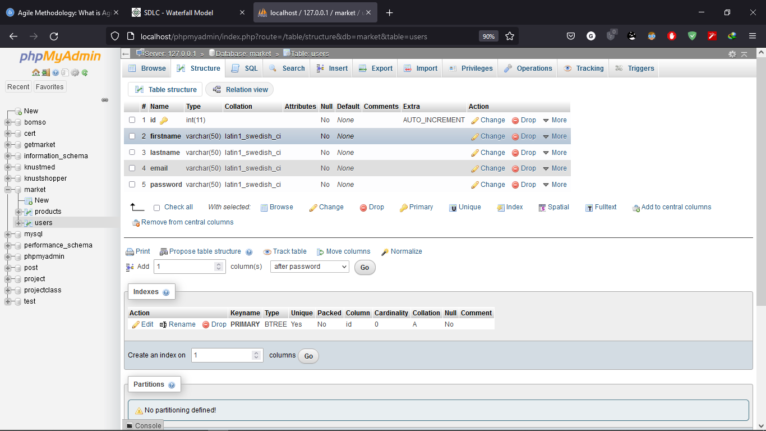

The products table

The products table consists of

* pid
* telephone
* product
* category
* categorytype
* location
* price
* description
* image

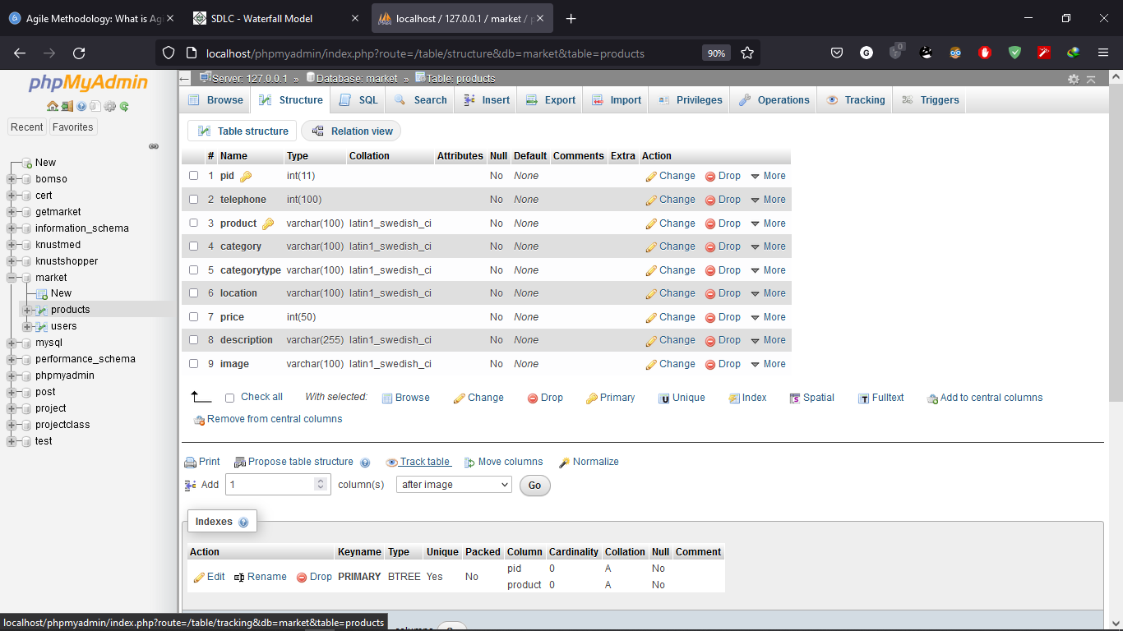

Database diagram:

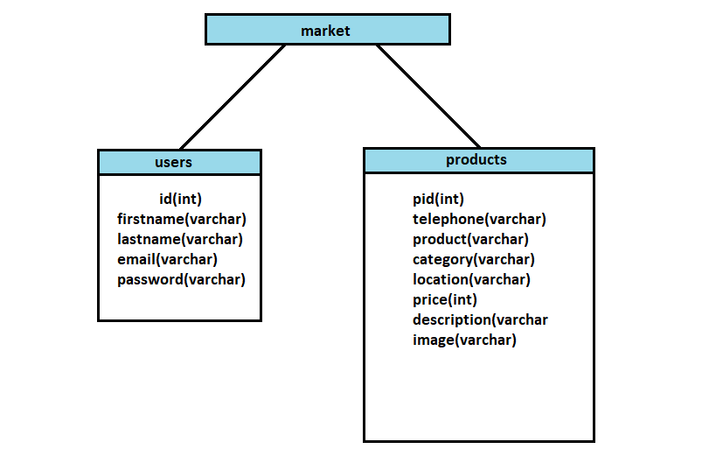

**USER INTERFACE DESIGN**

Login page:

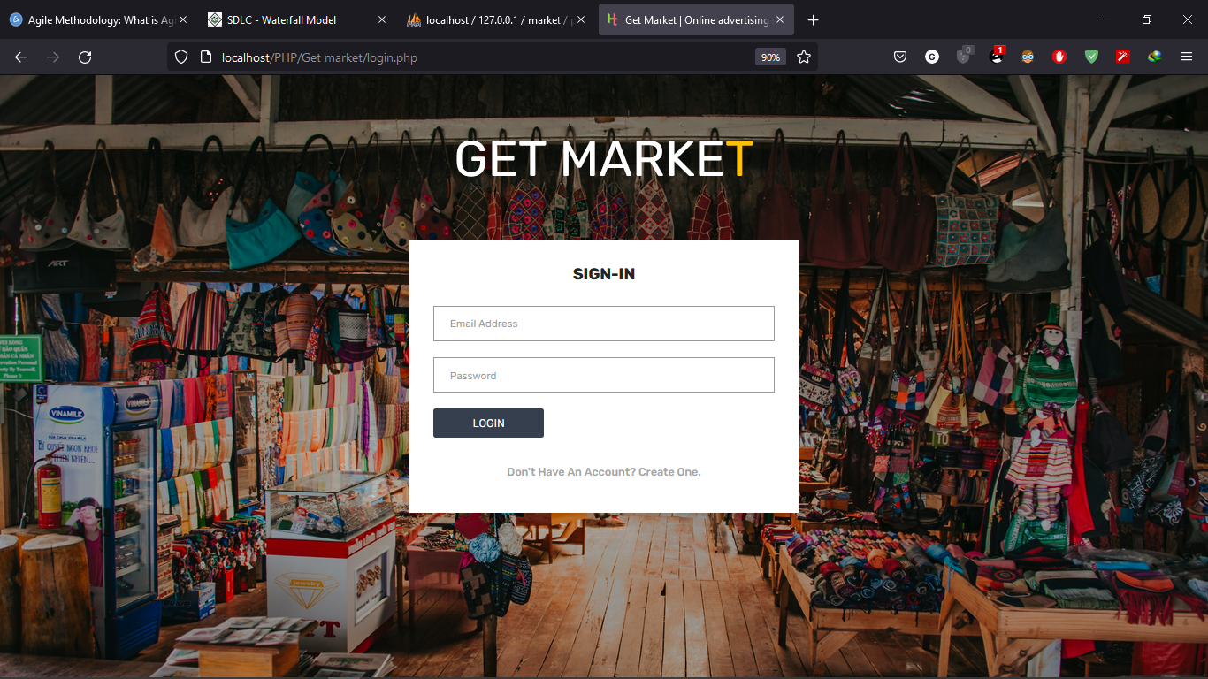

Register page:

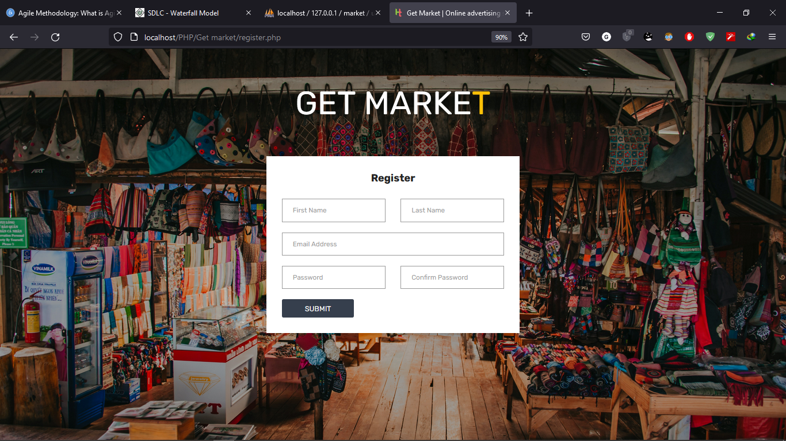

Home page:

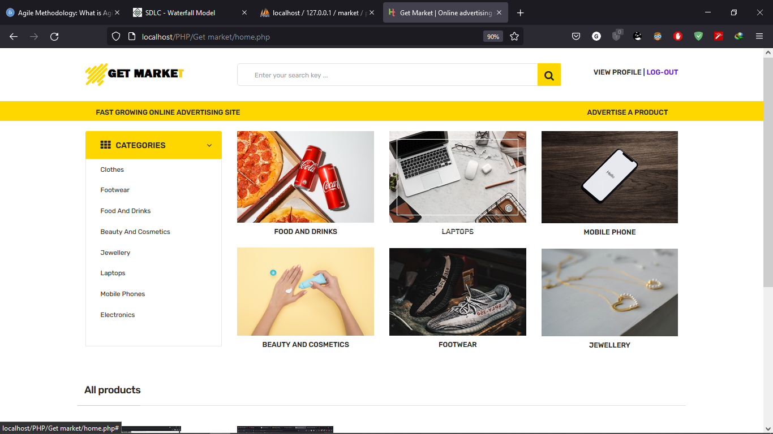

Edit profile page:

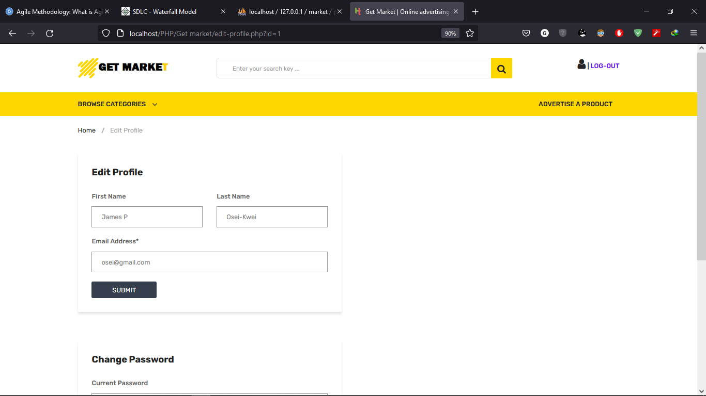

Add product page:

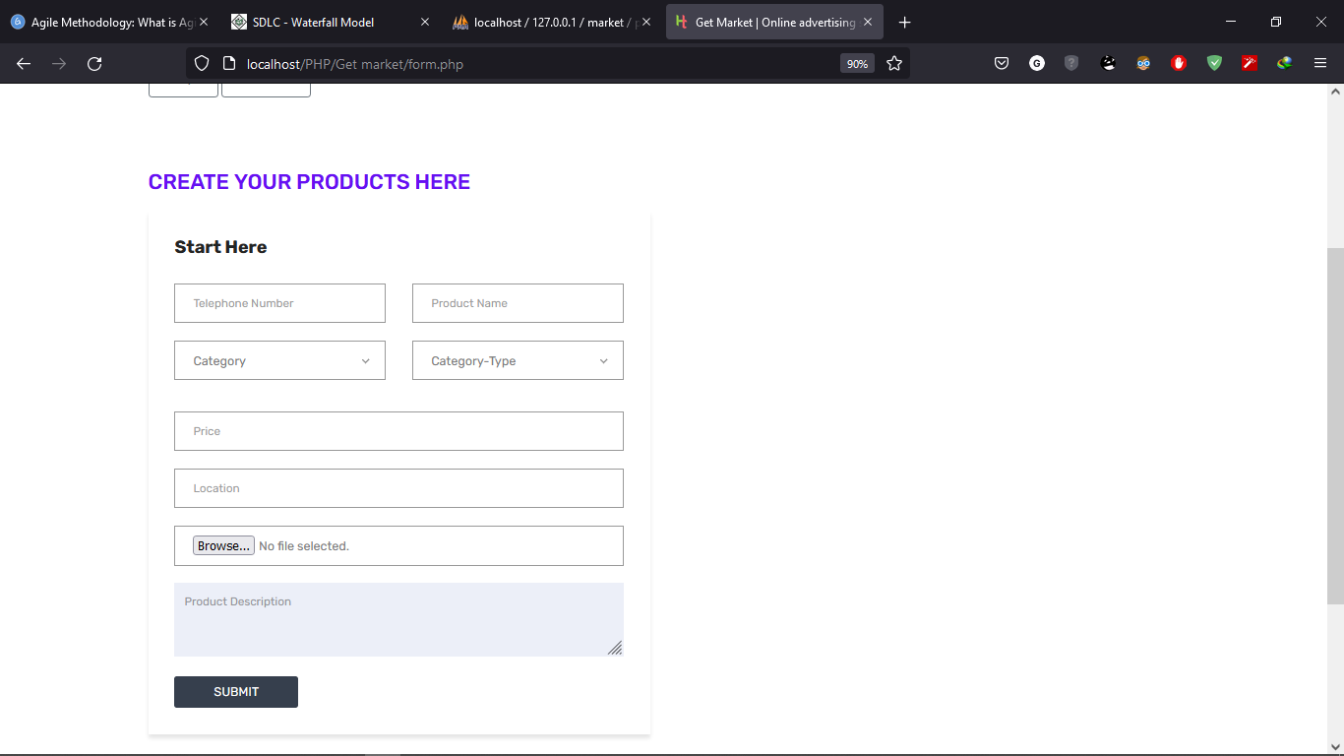

View product page:

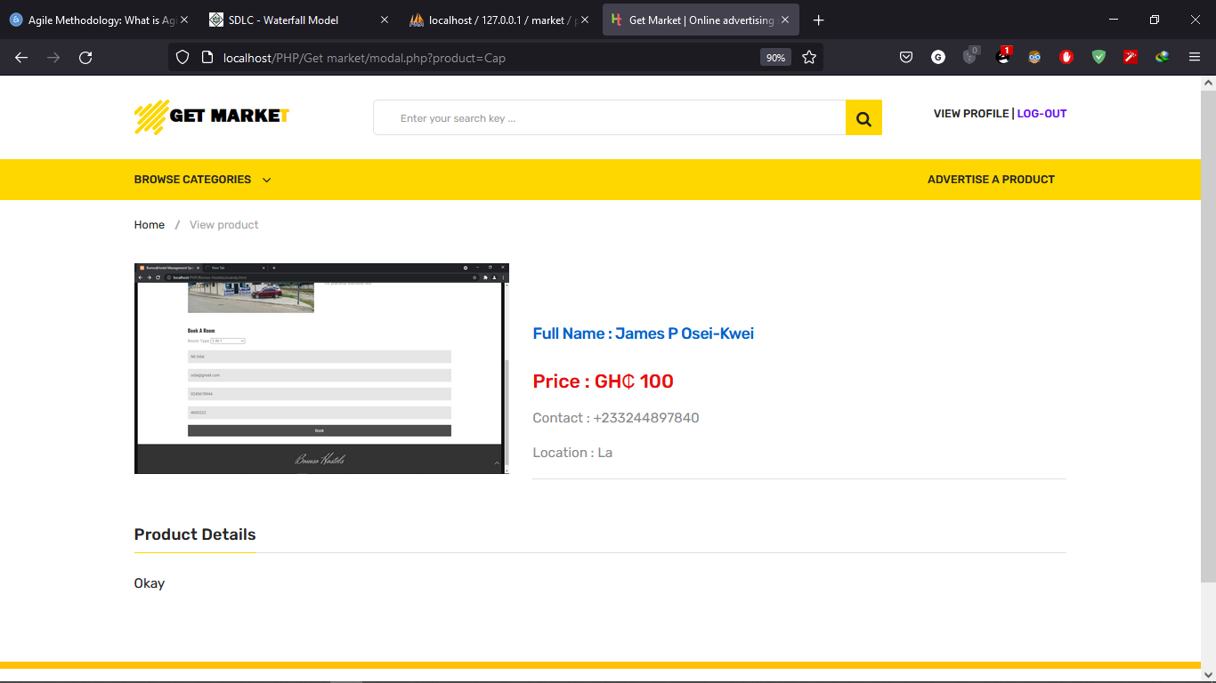

Edit and delete product page:

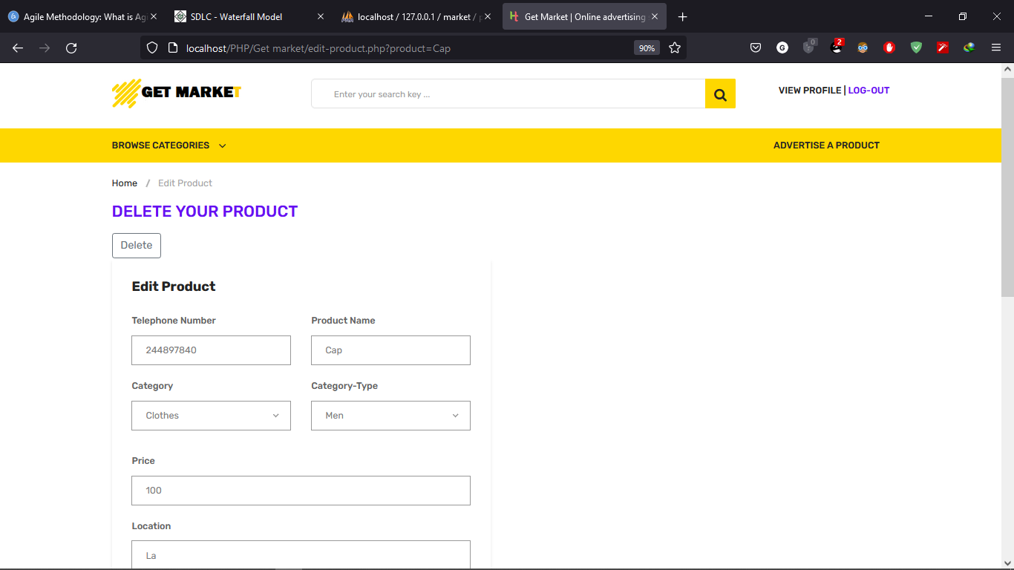

**CHAPTER FOUR**

**IMPLEMENTATION AND TESTING**

The implementation of the system consists of the development of a number of web-forms and database entries. The physical design specification is turned to a working code.

**DATABASE SCHEMA**

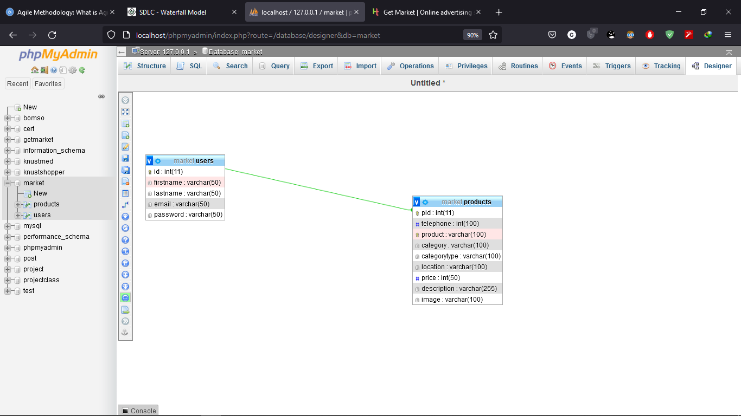

The users table is linked to the products table with a foreign key. The foreign key takes the primary key of the users table and links it to the product table’s primary key.

id: int(11) 🡪 pid: int(11)

The id from the users table and the pid form the products table.

**USER INTERFACES**

**TESTING**

User interface design is the overall process of designing how a user will be able to interact with a system. The goal of user interface design is to make the user's interaction as simple and efficient as possible, in terms of accomplishing user goals.

Process

We are creating an account under the following information

First name: James P

Last name: Osei-Kwei

Email: [osei@gmail.com](mailto:osei@gmail.com)

Password: 12345

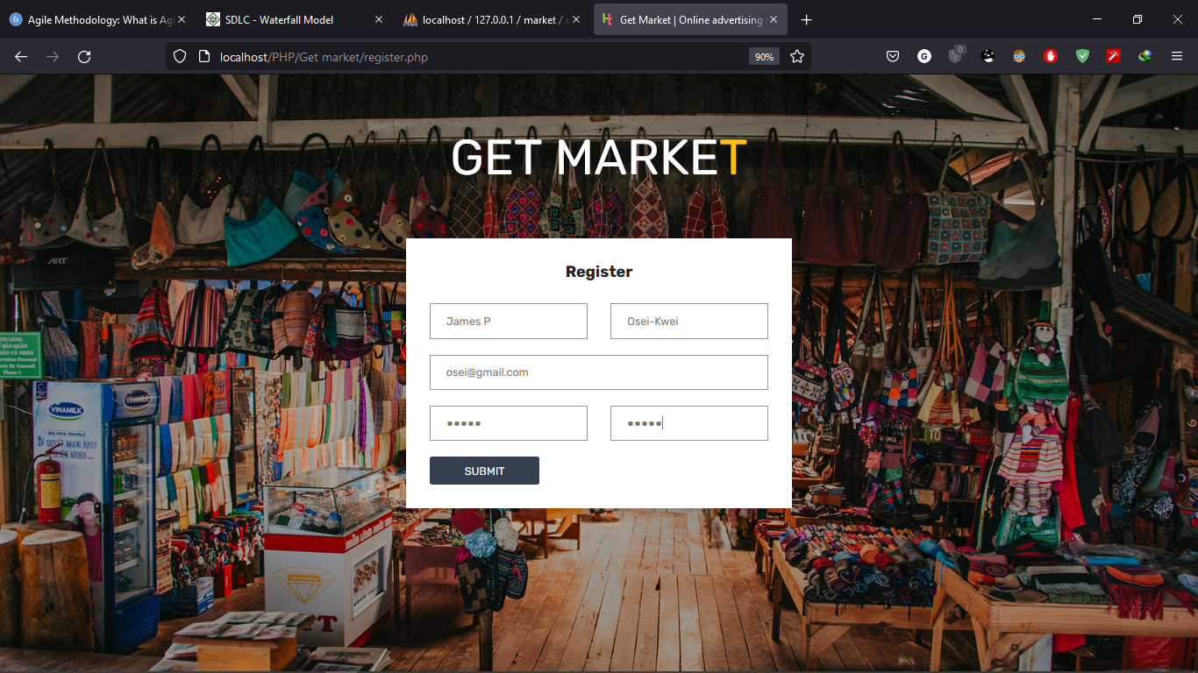

When the data entry meets the requirements, the user is sent to the home page. The information is entered into the database.

At the home page the user can surf to view products and their details.

Suppose the user wants to post his product and display under the following details.

Telephone: 0244897840

Product: Cap

Category: Clothes

Category type: Men

Price: 100 cedis

Location: La

Insert image

Description: Okay

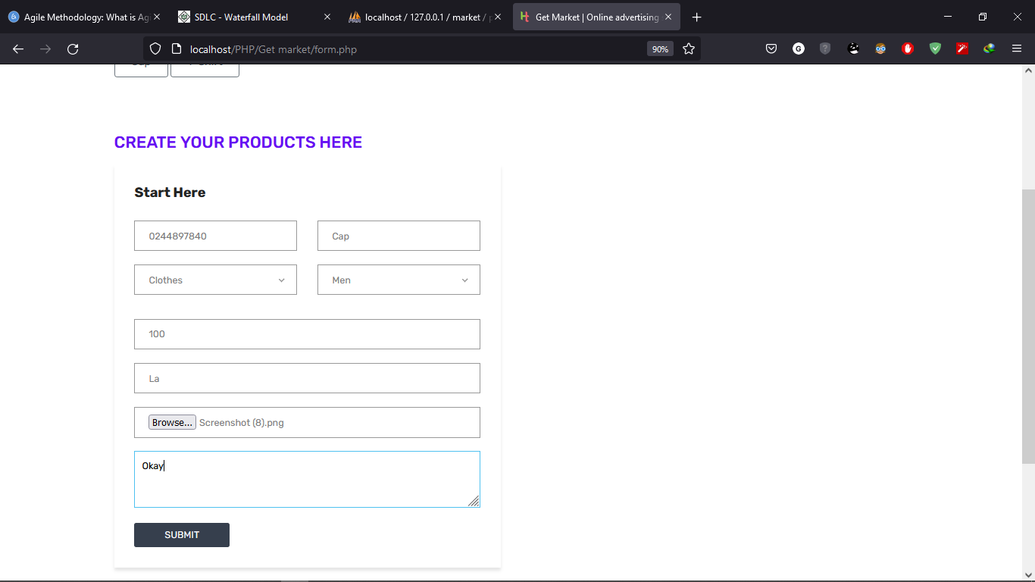

From here the user is sent back to the home page.

On the home page the product is displayed for the public to see and details can be viewed.

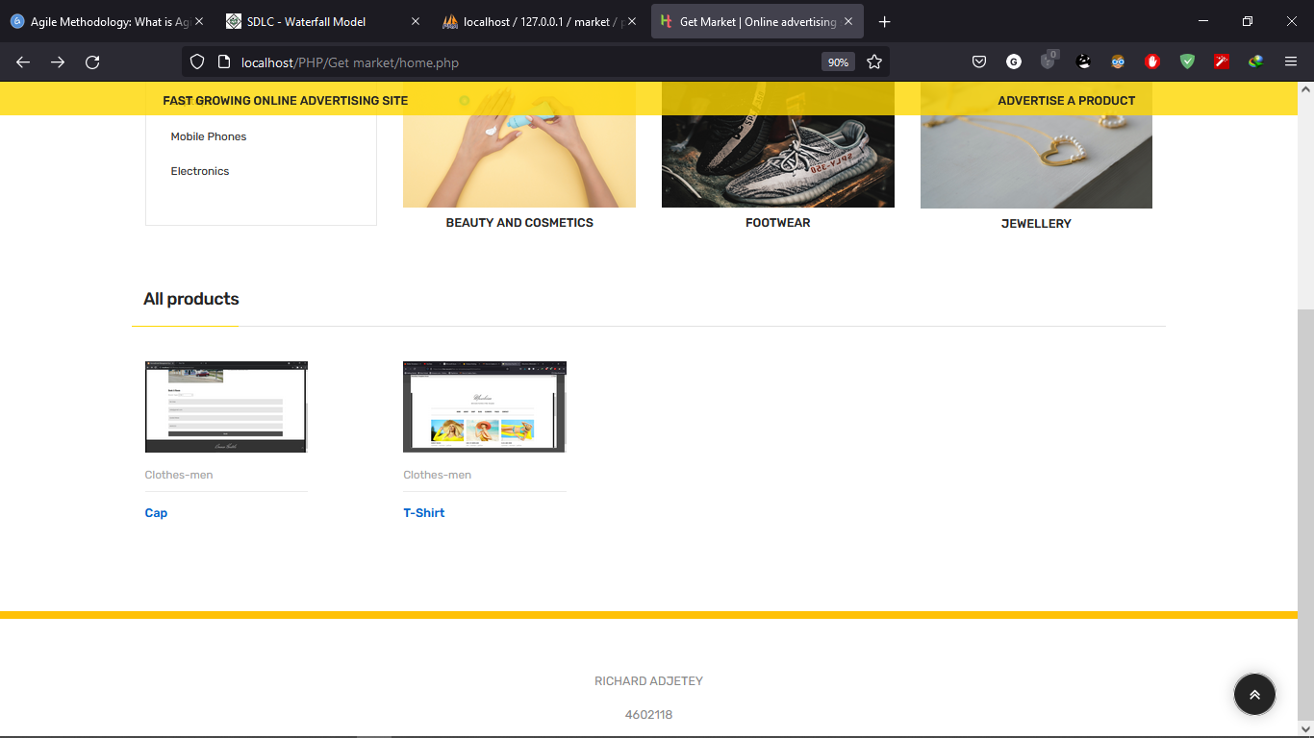

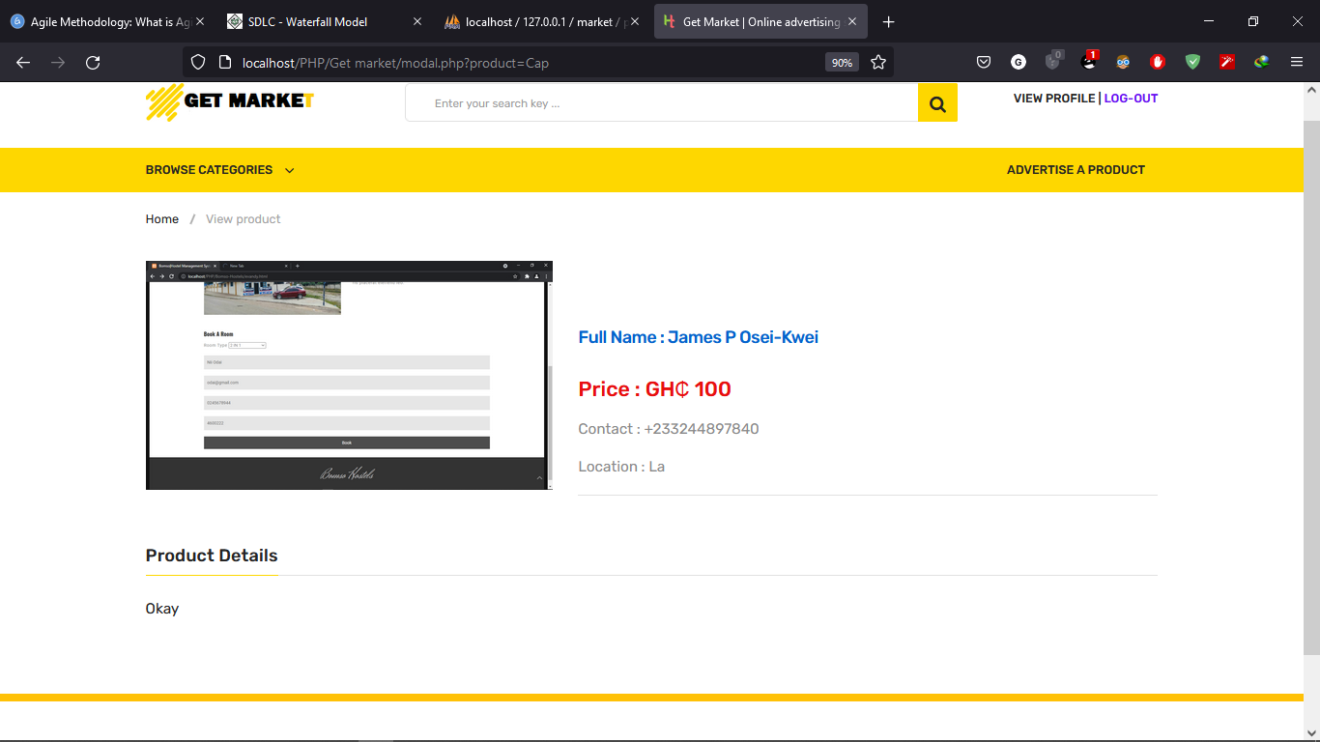

**DEPLOYMENT MODEL AND PLATFORMS**

The project can be run on any personal computer example; laptop or a desktop. To run the project, you will need the following;

1. Download and install XAMPP application.
2. Use any editor to view php code.
3. Download and install php on your personal computer.
4. In your web browser type; “localhost/phpMyAdmin” to access database management and create the database.
5. Create database “market” with tables “users” and products.

NB. Use the database design in chapter three for database context and entry creation.

1. In your local disk directory open the xampp folder and in htdocs create a folder called “Project” and insert the project files.
2. Type “localhost/Project/Get market/login.php” in your browser to run the project.

Get market folder

1. css: contains css files.
2. fonts: contains the various fonts format.
3. js: javascript files
4. upload: folder for uploading images
5. delete.php: code for delete process
6. edit2.php: code for editing images
7. edit-product.php: code for editing product displayed
8. edit-profile.php: code for editing profile and changing password
9. form.php: code for form entry.
10. home.php: code for home page interface.
11. log.php: code for login.
12. login.php: code for login interface.
13. modal.php: code for product view page.
14. reg.php: code for registering user.
15. register.php: code for register interface.
16. search.php: code for search and search interface

**CHAPTER FIVE**

**CONCLUSION AND REFERENCES**

**CONCLUSION**

The project titled Get market is easy to use and access i.e. no need of detail computer skill to use and access. The project aim is to build a web-based system to allow students to advertise products they want to sell that is a business platform for more publicity. Get market has greater functionalities to enhance effectiveness and efficiency related to the aim stated. The project achieves the objective listed on the document, functional and non-functional requirements, and the insight into the development.

**REFERENCES**

[**https://www.w3schools.com/**](https://www.w3schools.com/)

[**https://www.guru99.com/agile-scrum-extreme-testing.html**](https://www.guru99.com/agile-scrum-extreme-testing.html)

[**https://www.tutorialspoint.com/sdlc/sdlc_waterfall_model.htm**](https://www.tutorialspoint.com/sdlc/sdlc_waterfall_model.htm)

[**https://www.studentstutorial.com/php**](https://www.studentstutorial.com/php)

[**https://scholar.lib.vt.edu/ejournals/JITE/v40n3/howell.html**](https://scholar.lib.vt.edu/ejournals/JITE/v40n3/howell.html)